*Preeti Sethi*

*Artist/ Sculptor/ Ceramist/ Potter/ Print Maker/ Metallurgist/ Crafter/*

*Art Therapist/ Mental Health Artist*

*ART IMAGES & SCULPTURES*

*[Document Subtitle]*

Title:

Size : 24x30”

Medium: Oil on Canvas

Price: 70,000/-

Was selected for exhibiting at the XIV th Florence Biennale Italy 2023 but I did not participate due to personal reasons)

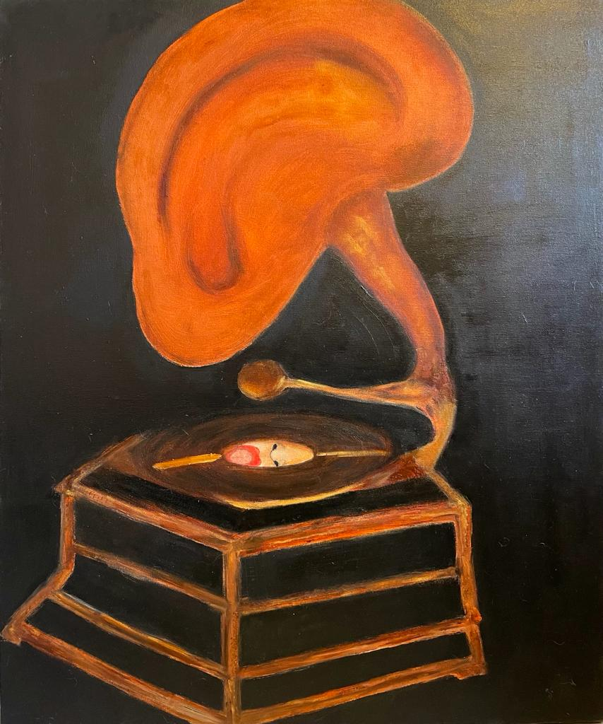

Title: Moods

Size : A4

Medium: Print on Archival Paper

Price: 15,000

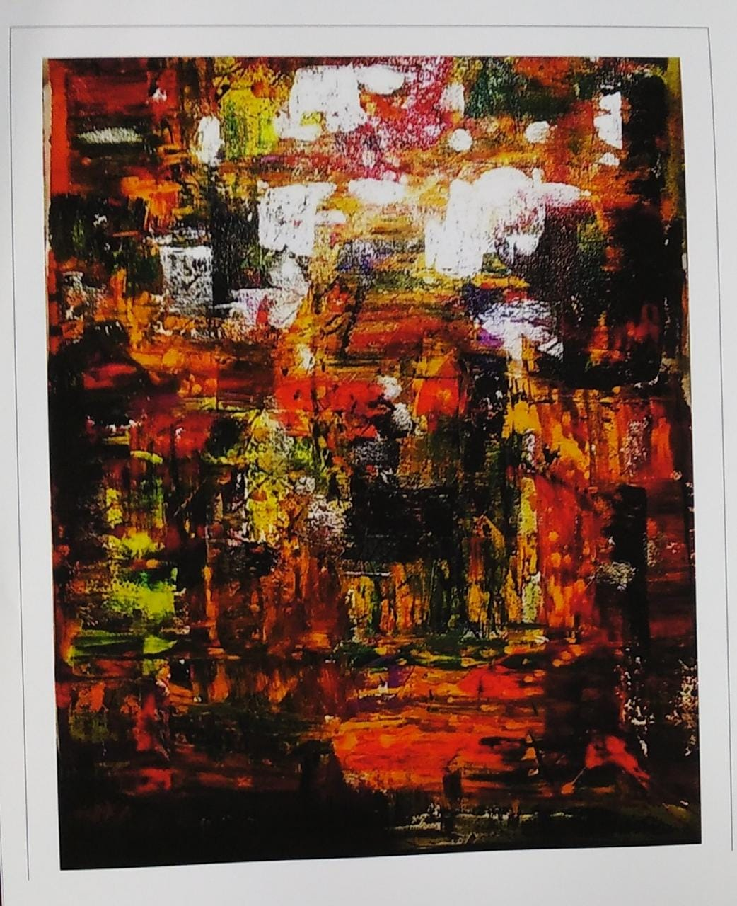

Title: The Leap

Size: 24x36”

Medium: Mixed Media (Brass Metal Art) on Canvas

Price: 2,95000

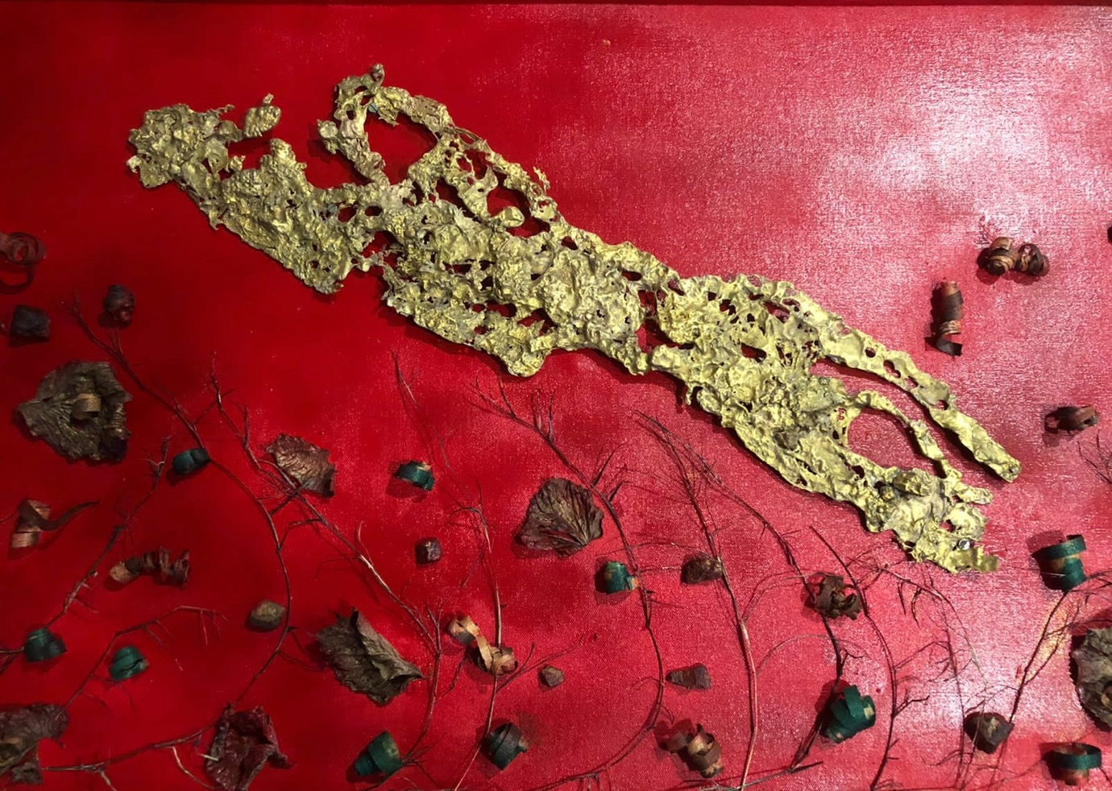

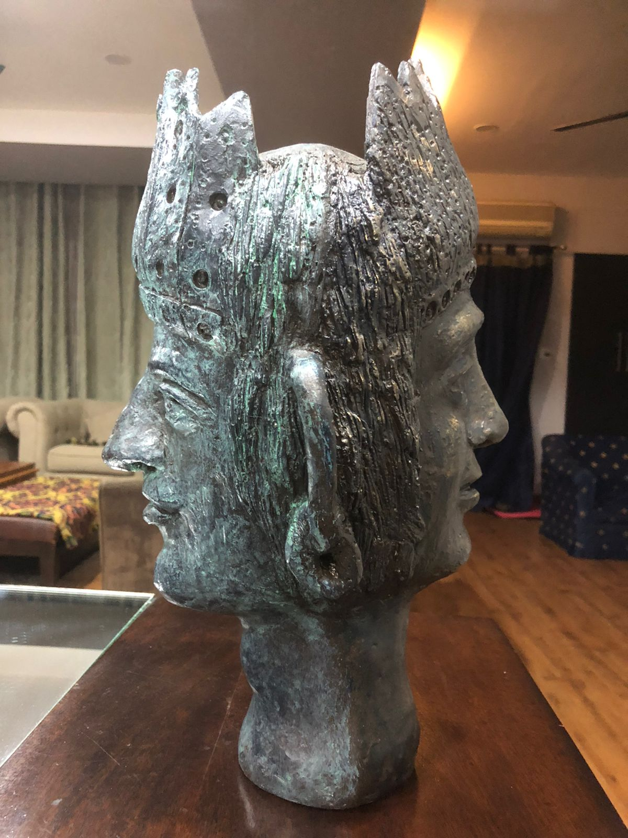 Title: Amba’s Pratishodh/ 18” Fibre

Price: 1,25,000/-.

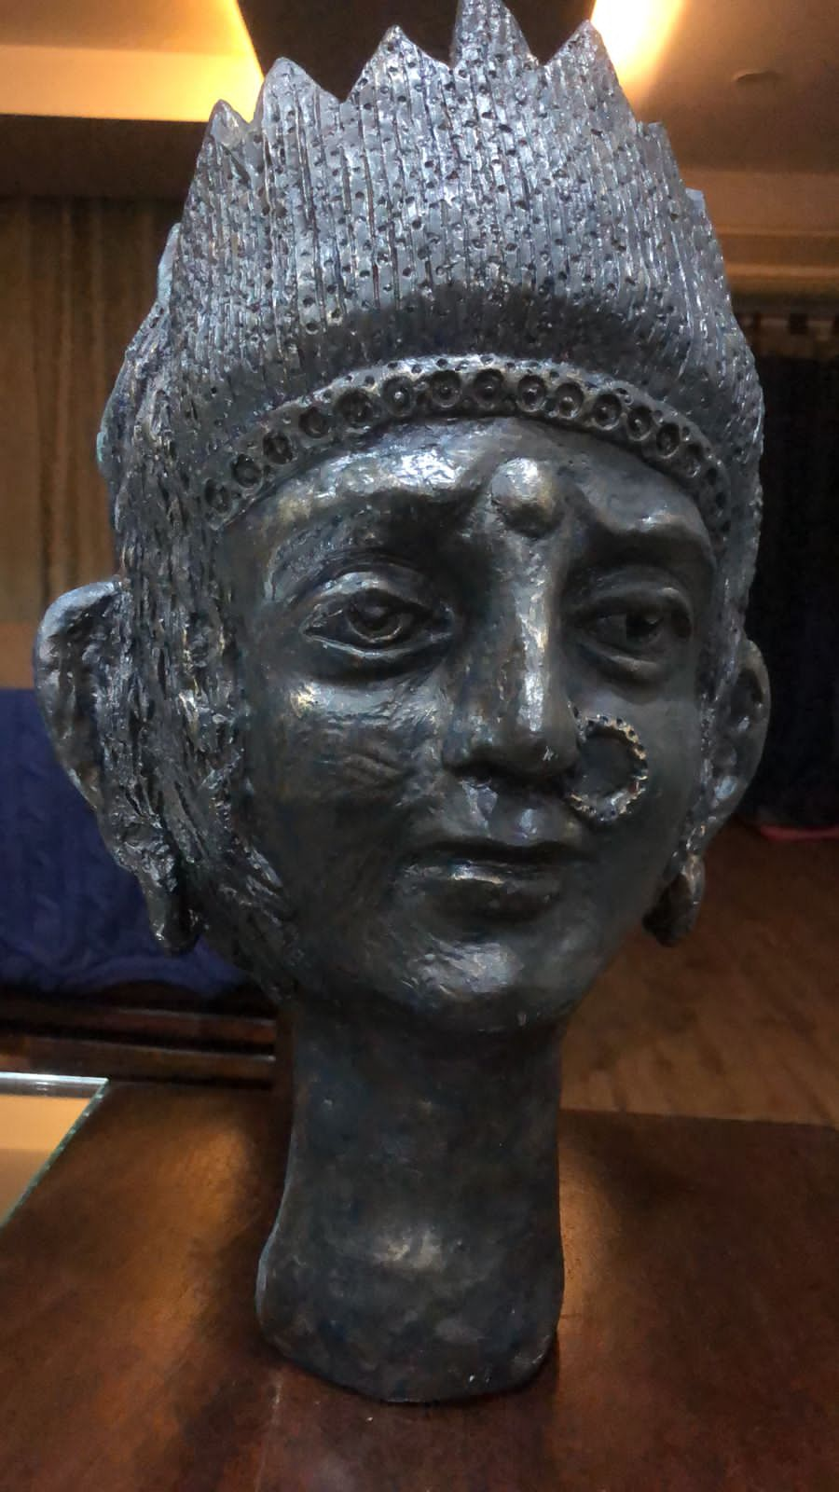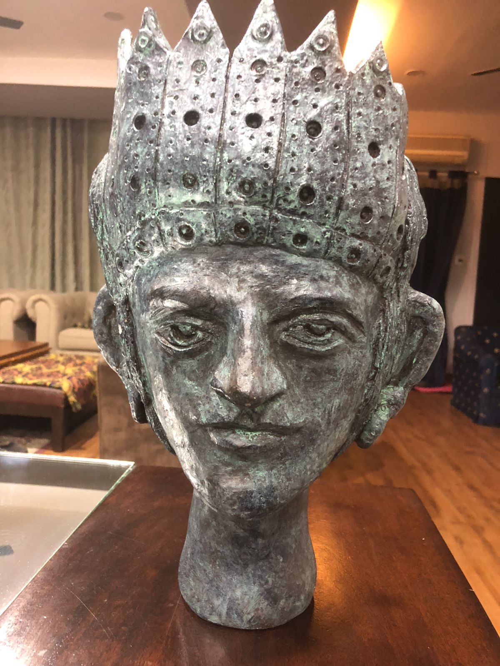

Title: Karma

Size: 3x4’

Medium: Mixed Media on Canvas

Price: 1,10,000/-

Was selected to be exhibited at the XIV th Florence Biennale Italy 2023 ( I did not participate due to personal issues)

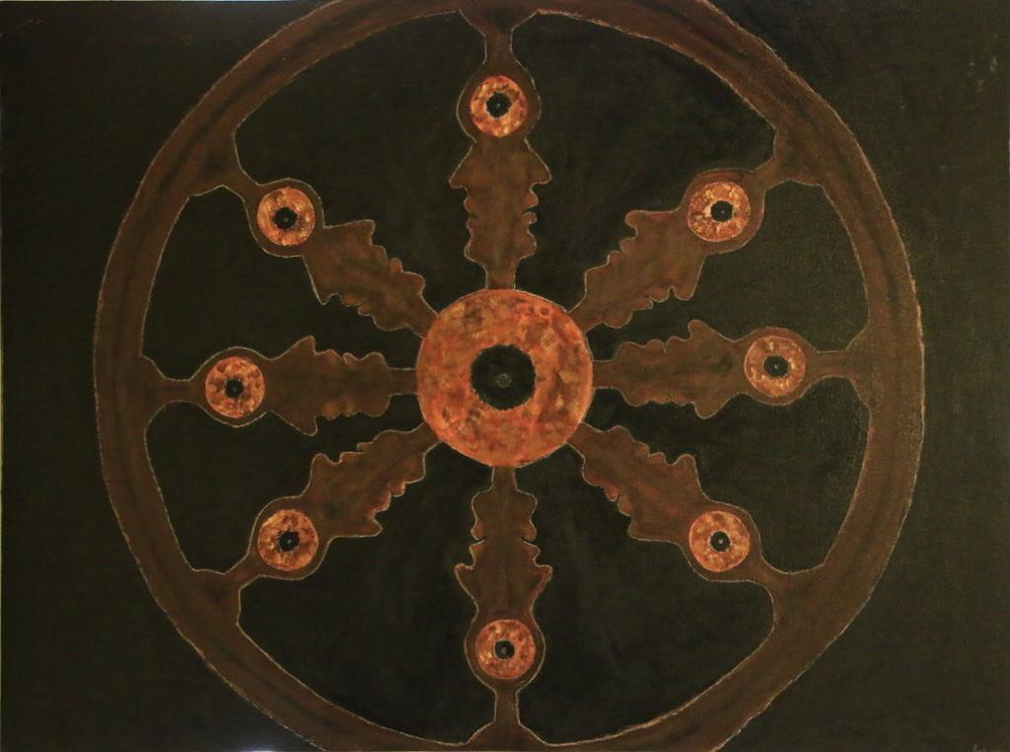

Title: It’s a Girl!!!!

Size: 12x12”

Medium: Mixed Medium Clay Sculpture ( based on Female infanticide and abortion). Was exhibited at the XIIIth Florence Biennale Italy 2021.

Price: On Request

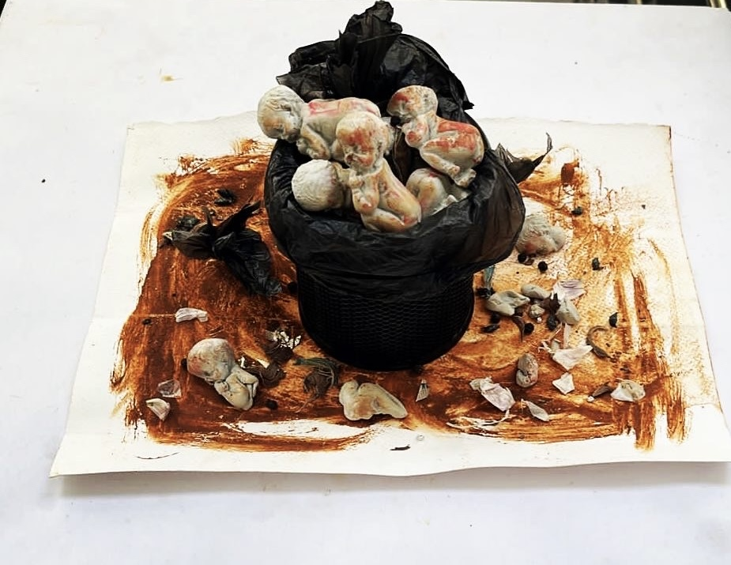

Title: Might

Size: 10x10”

Medium: Mixed Media on Paper

Price: 25,000/-

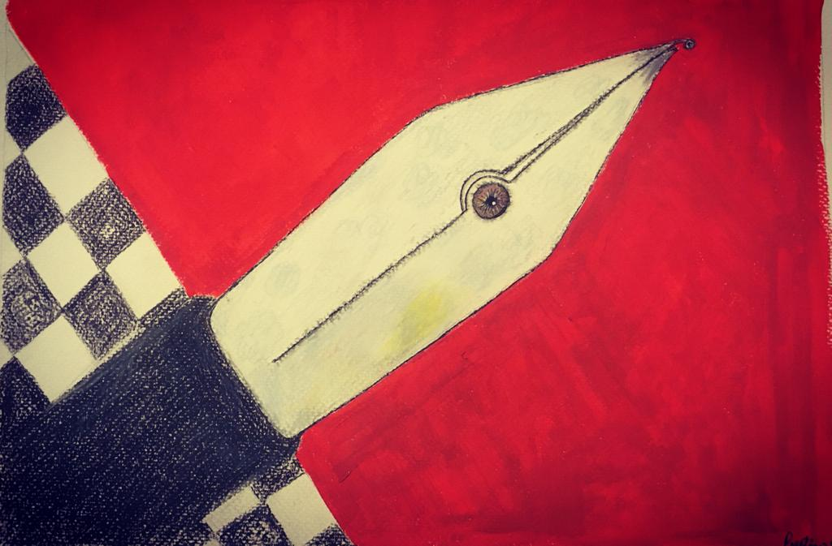

Title: Lust

Size: 10x10”

Medium: Mixed Media on Paper

Price: 35,000/-

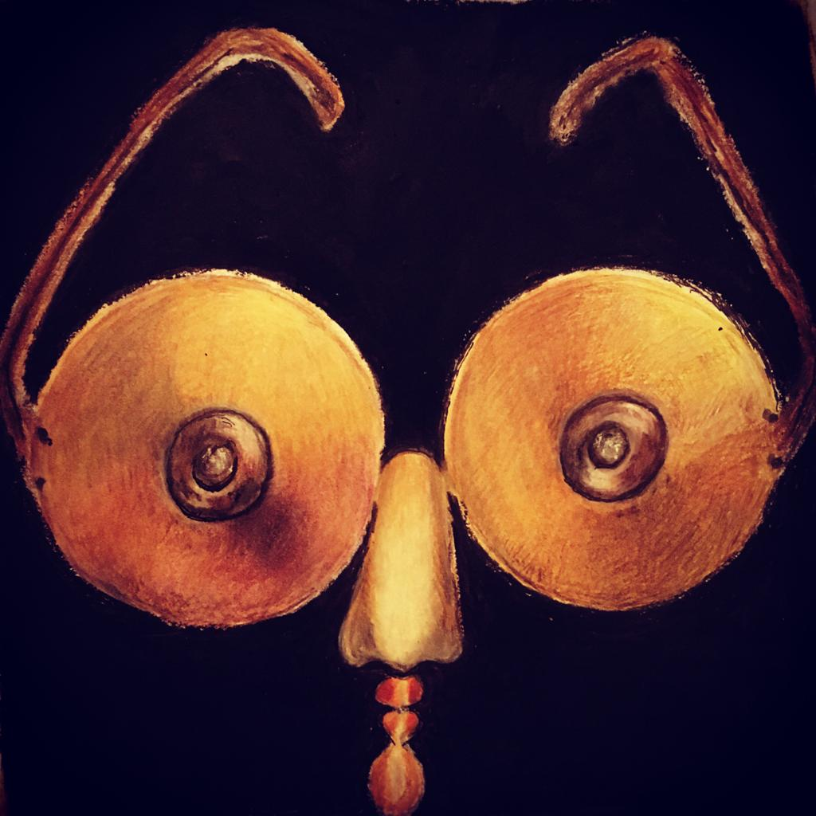

Title: Tattered Wings and Shattered Dreams

Size: 10x10”

Medium: Color Pencils on paper

Price: 35,000/-

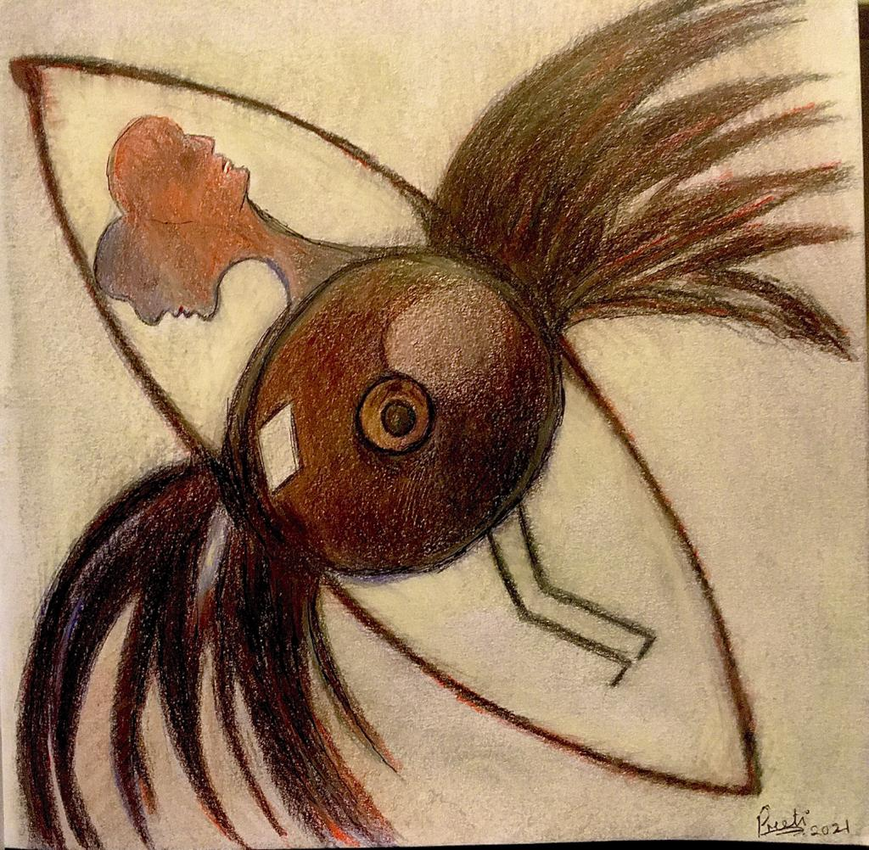

Title: Eklavyas Gurudhakshina

Size: 18”

Medium: Fibre Sculpture (available in Brass/Bronze on request, price would differ)

Price: 1,05000/-

From my series on the Mahabharath

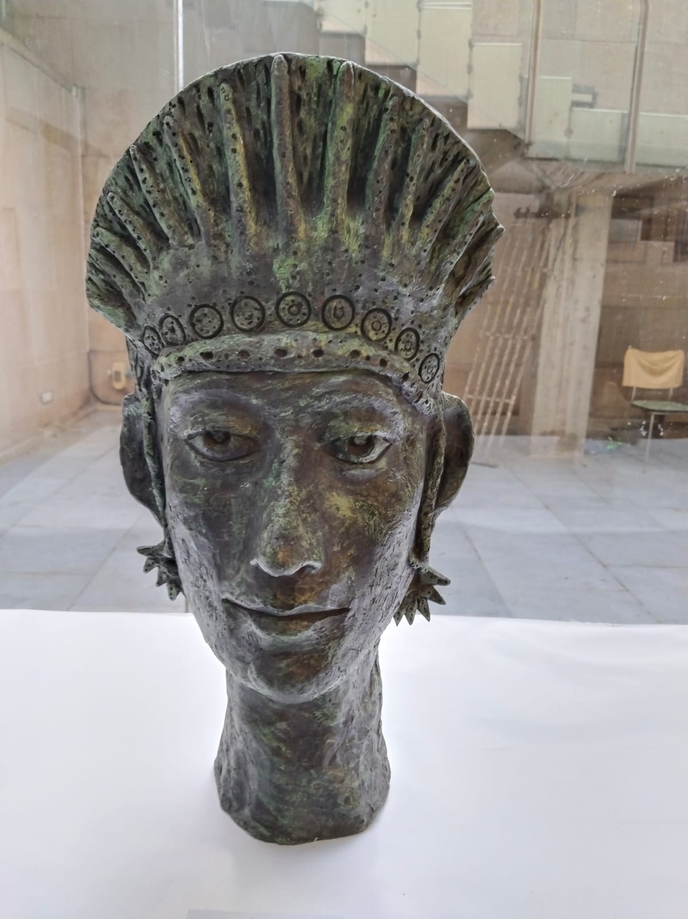

Title: Pawns-1

Size: 12x12”

Medium: Acrylic on Canvas

Price: 25,000/-

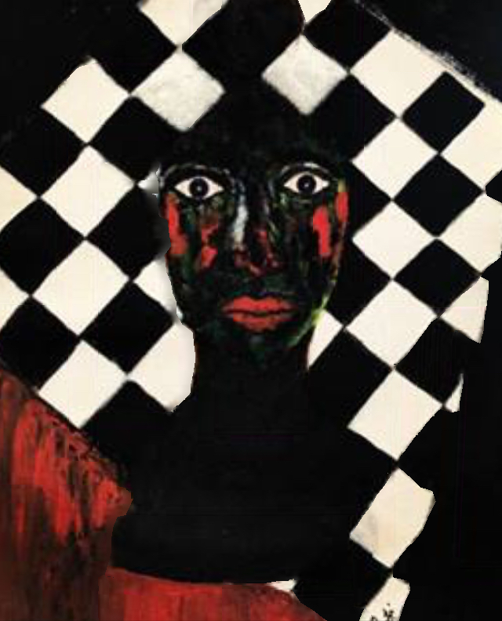

Title: Scars-2

Size: 10x10”

Medium: Mixed Media on Paper

Price: 25,000/-

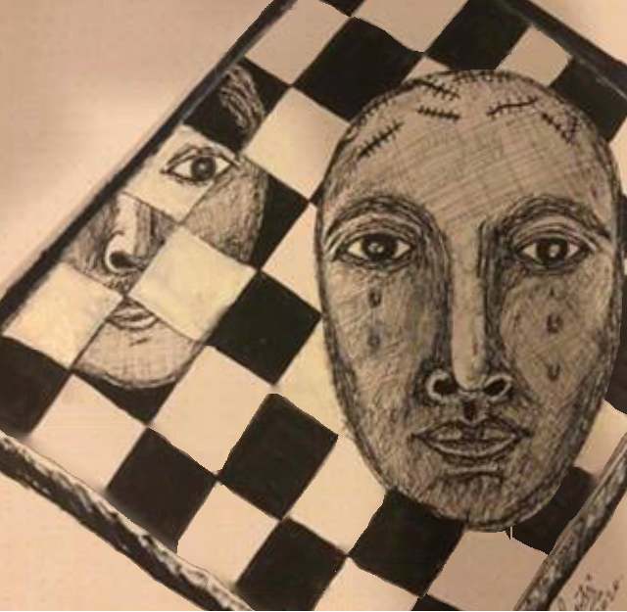

Title:

Size: 12x12”

Medium: Metal Art ( Brass on Copper sheet)

Price: 55,000/-

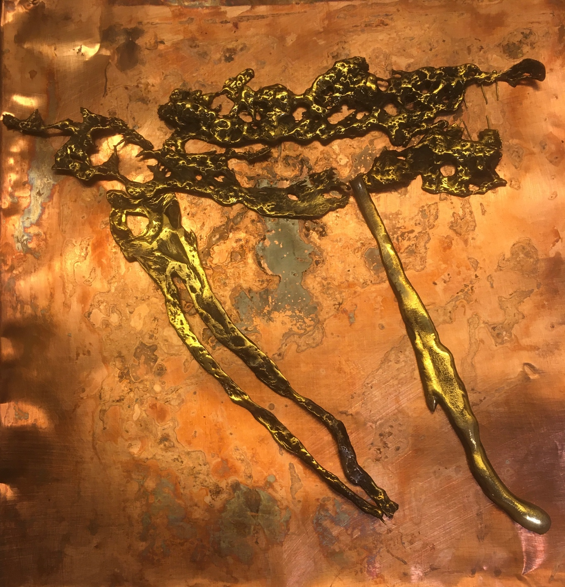

Title: Restructuring Nature

Size: 12x12”

Medium: Metal Art ( Copper)

Price: 28,000/-

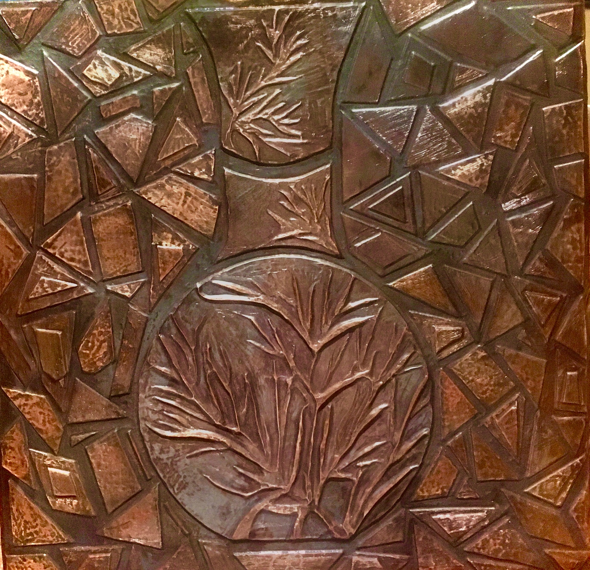

Title: Dhitrashtra’s Mahatvakanksha

Size: 10” approx

Medium: Fibre Sculpture ( on request in Metal -Brass/ Bronze, price would differ)

Price: 95,000/-

From my series on the Mahabharath

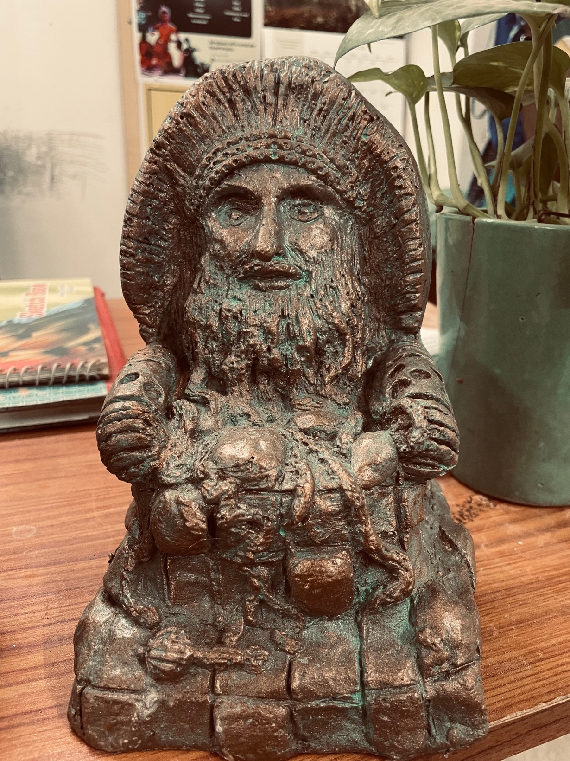

Title: Bondage

Size: 11.7x16.5”

Medium: Color Pencil sketch on Paper

Price: 15,000/-

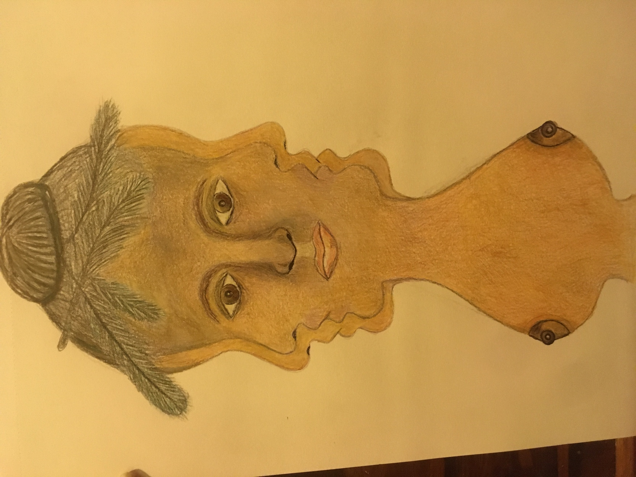

Title: Reflections

Size: 11.7x16.5” approx

Medium: Color pencil Sketch on paper

Price: 65,000/-

Was selected for the XIIIth Florence Biennale Italy 2021 but I sent only 2 works.

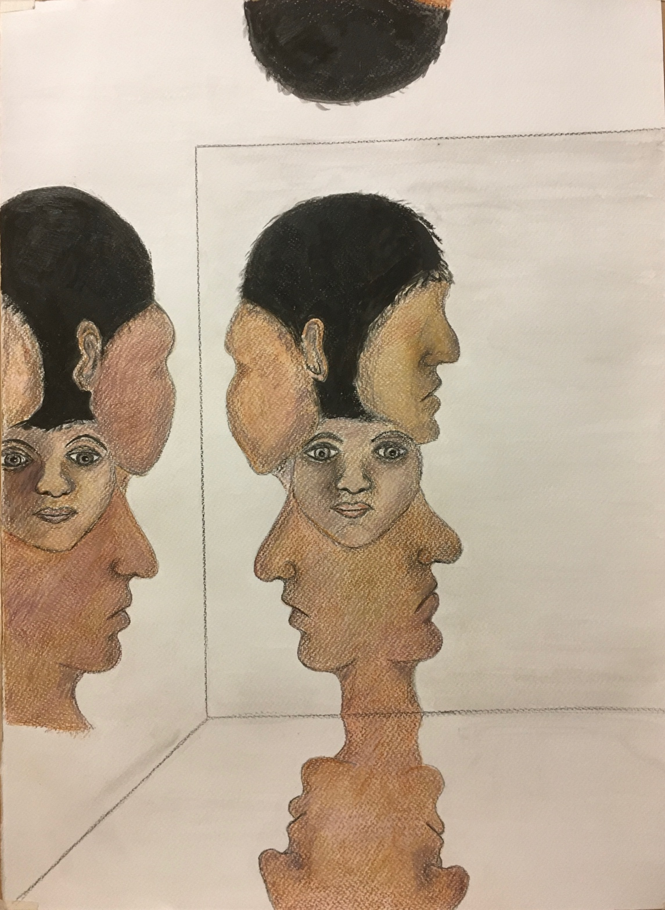

Title: Pawns

Size: 7x9”

Medium: Original Print on paper

Price: 20,000/-

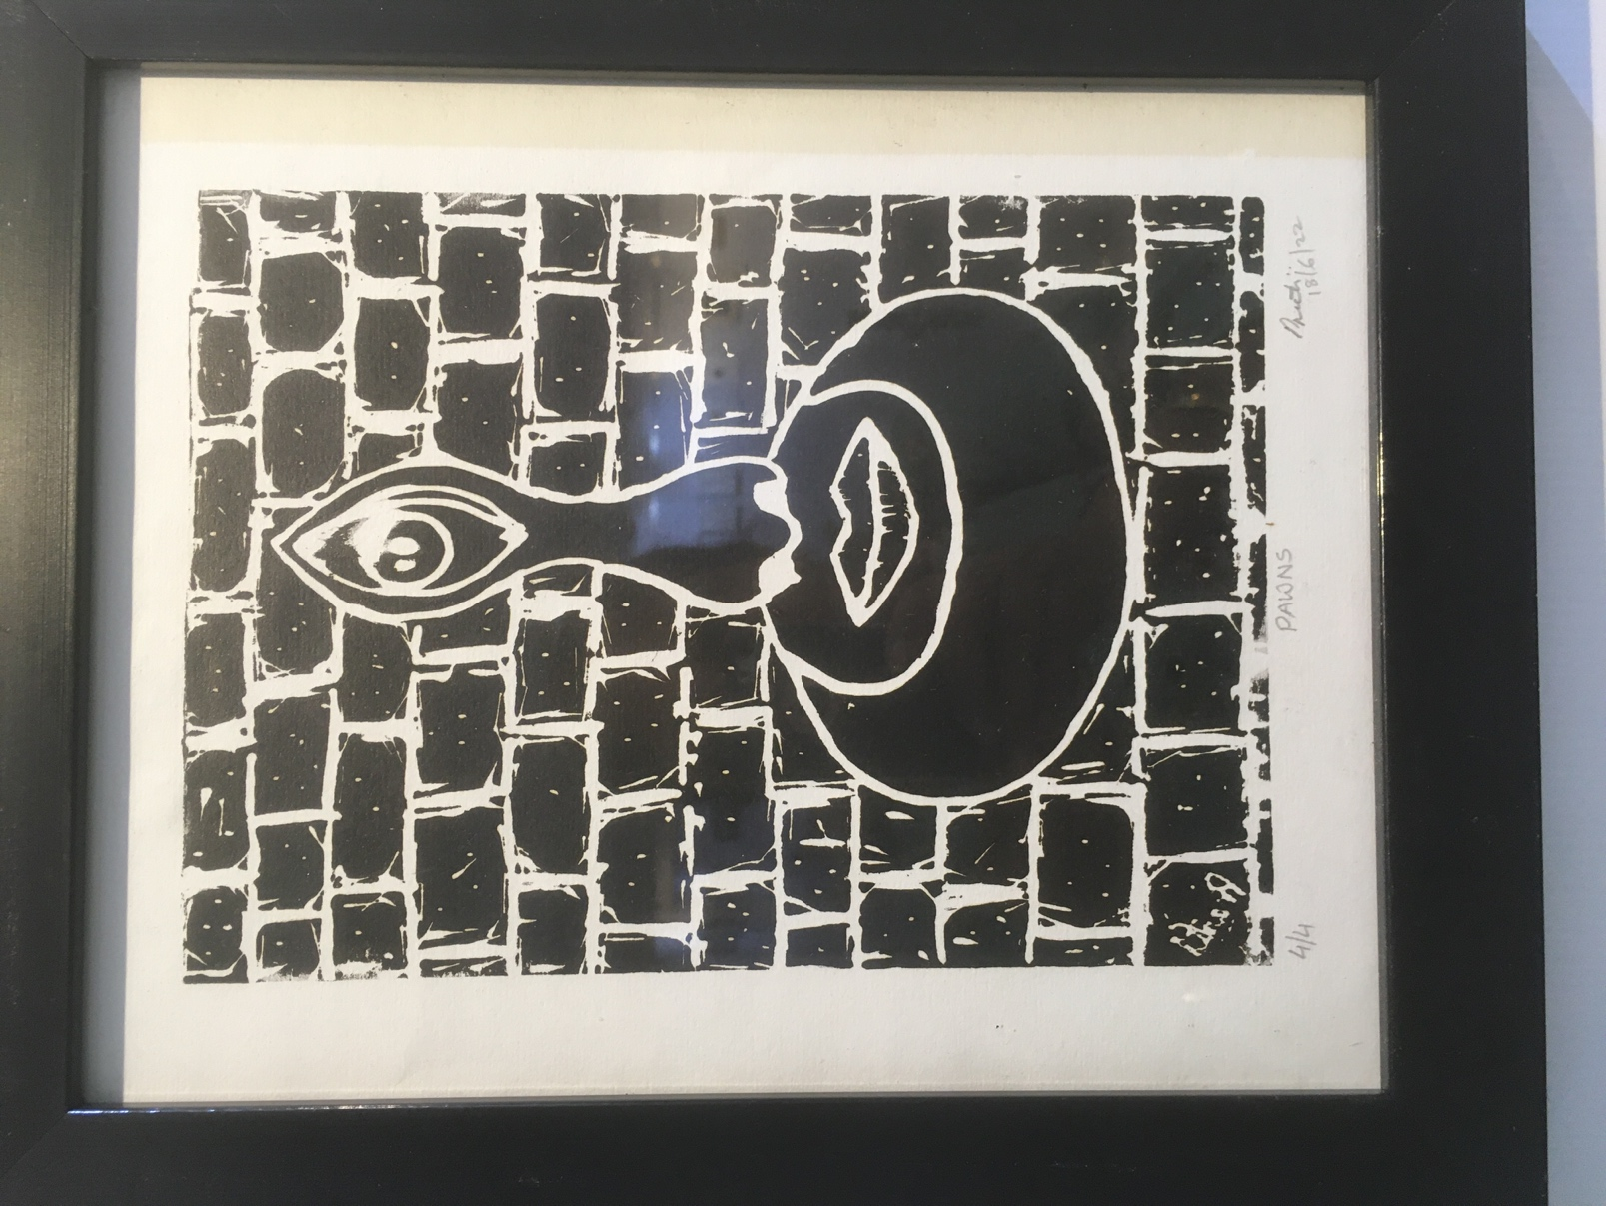

Title: Watchful

Size: 12x12” approx

Medium: Original print on fabrino paper

Price: 15,000/-

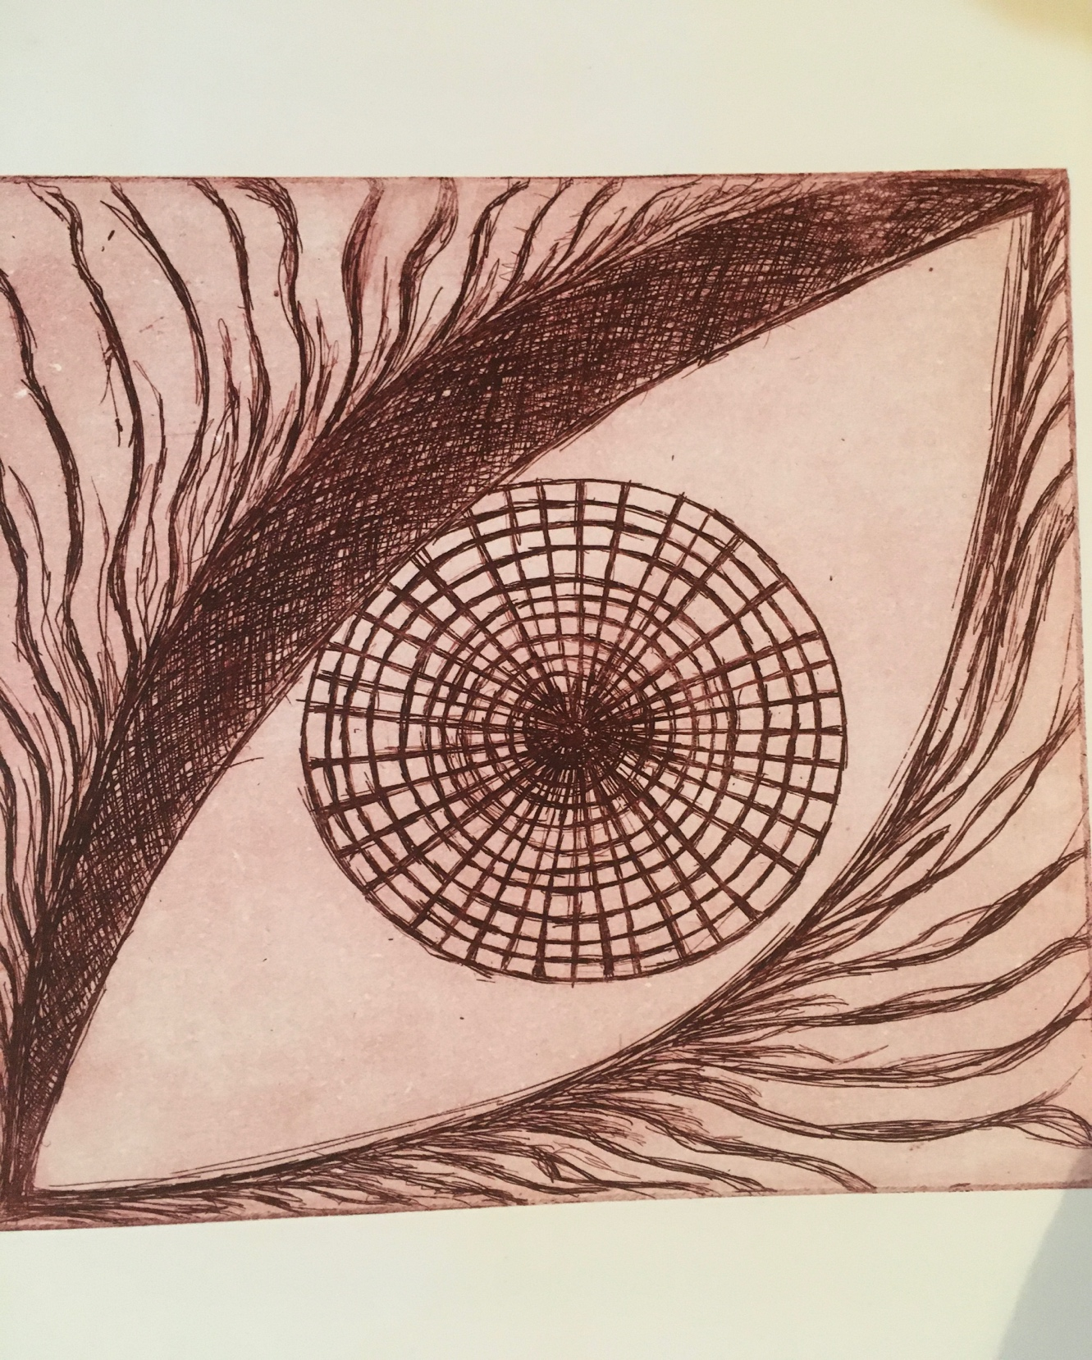

Title: The Market Place

Size: 11x16” approx

Medium: Ink and Charcoal on Paper

Price: 40,000/-

